Comparative genomics final report

by Shuhan Xu, Fuqi Xu, Milda Valiukonytė

In this project, we have performed an analysis of five genomes, including their genetic composition (GC content, nucleotide, dinucleotide and diaminoacid frequencies), prediction of open reading frames and calculation of distances between genomes to understand the evolutionary relationships between species. We wrote three Python scripts for this purpose, named GC_content.py, ORF_predictor.py and distance.py (see attachments).

The five genomes included four prokaryotes and one eukaryote: Escherichia coli of Enterobacteriaceae bacterial family (genome length 5443340 bp), Streptomyces coelicolor of Streptomycetaceae family (9054847 bp), Rubrobacter xylanophilus of Rubrobacteraceae family (3225748 bp), Spiribacter curvatus of Ectothiorhodospiraceae family (1926631 bp), and Saccharomyces cerevisiae from Saccharomycetaceae yeast family (1531933 bp).

The genetic composition analysis has shown that there is a great variation among the five genomes in terms of their GC content, nucleotide, dinucleotide and diaminoacid frequencies. The GC content was calculated using the formula . The highest GC content was found in Streptomyces coelicolor, while Saccharomyces cerevisiae had the lowest GC content. (Fig 1.)

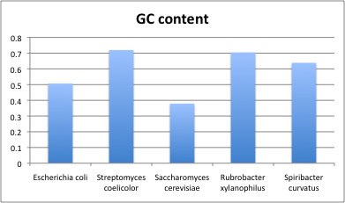
Fig 1. GC content among genomes

Dinucleotide frequencies were calculated using formula:

The results have shown that bacterial species are rich in CC, CG, GC, GG dinucleotides, which is in line with the GC content results. Overall, we have observed great differences between dinucleotide frequencies among species which can indicate that dinucleotide frequency pattern is species-specific (Fig 2). Similar patterns have been observed in nucleotide and amino acid frequency distributions (Fig 3 and Fig 4).

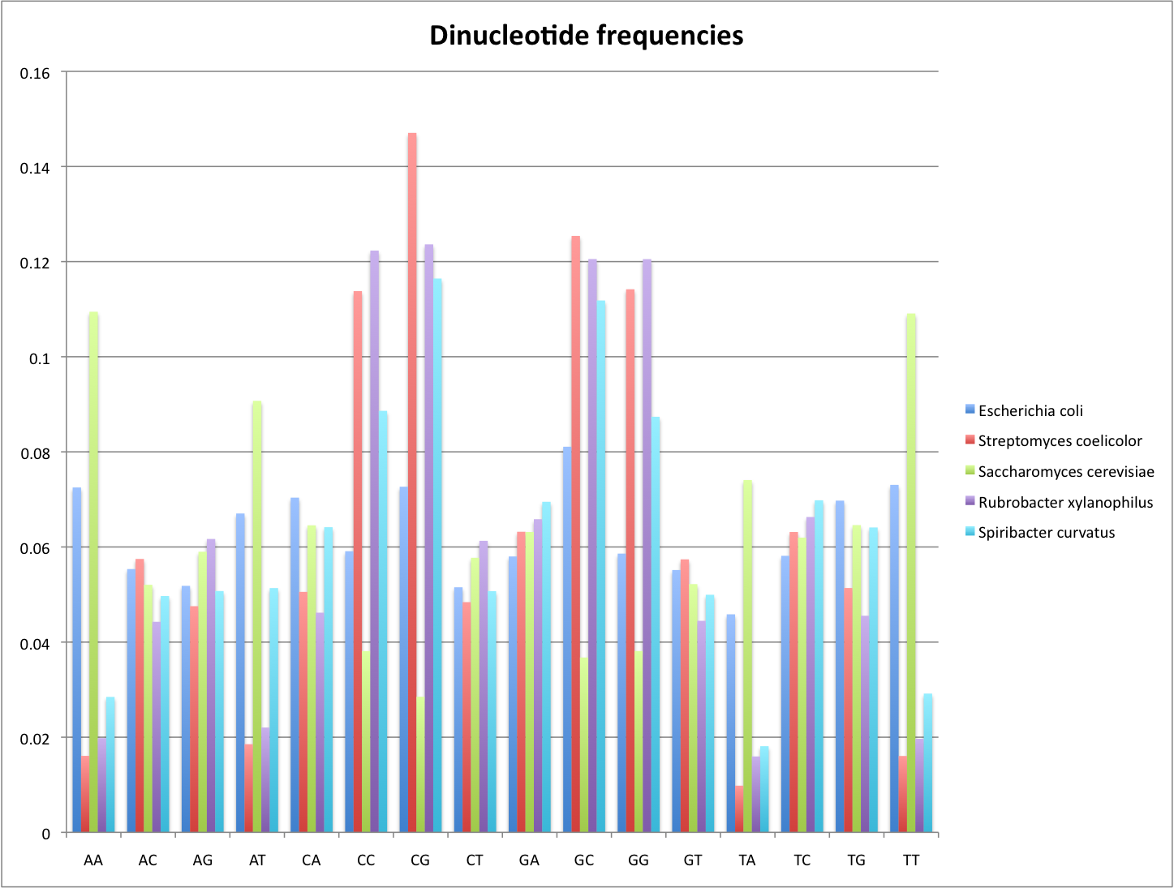

Fig 2. Dinucleotide frequencies among genomes

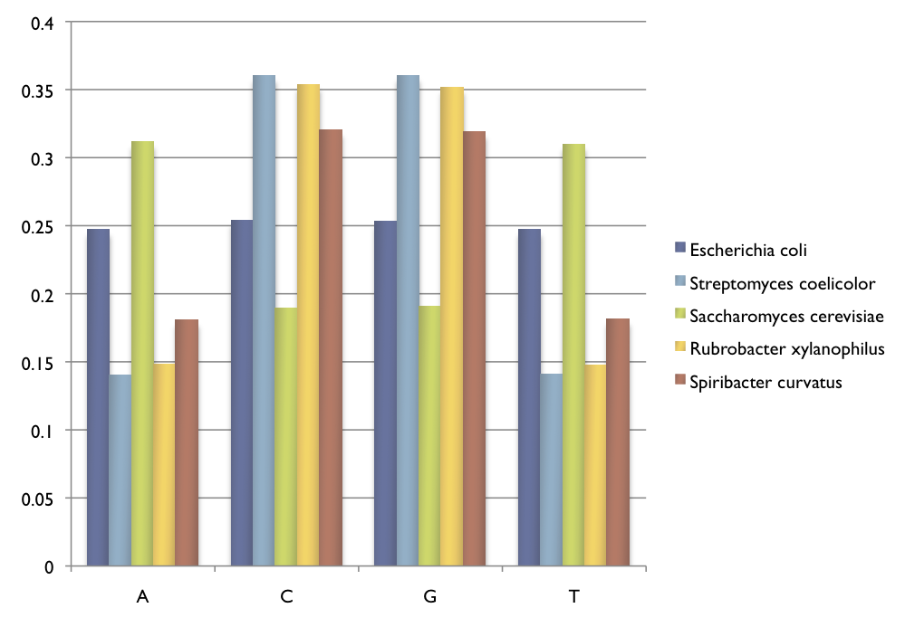
Fig 3. Nucleotide frequencies among genomes

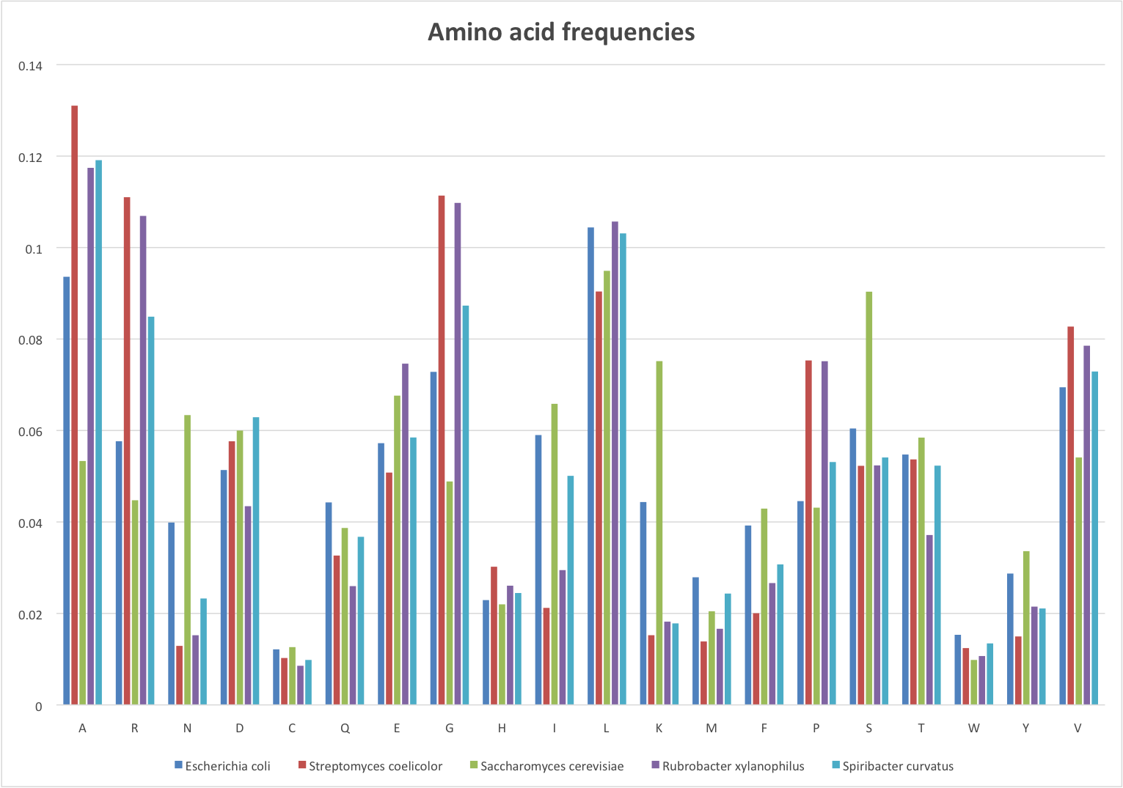
Fig 4. Amino acid frequencies among genomes

Next, we used our own written script to predict open reading frames (ORFs) in our genomes. For the prediction, we made the following basic assumptions. First, An ORF starts with start codon (TAC) and ends with stop codons (ATT, ACT, ATC). Second, the minimum length of genes in prokaryotes is 200bp, 300bp in eukaryotes (excluding the stop codons). Third, in the same reading frame, if there are overlapping genes sharing the same stop codons. the longest ORF is the one we are looking for. Fourth, in different reading frames, the maximum overlapping length is 60bp. Fifth, in different reading frames, if maximum overlapping length is greater than 60bp, we keep the longer ORFs. Table 1 summarizes the ORF prediction across genomes.

Table 1

The prediction evaluation contains two parts. Firstly, we compared our prediction results with the prediction results of GLIMMER. Then we compared our predicted genes with the proteome of the five species.

1) Comparison with GLIMMER

True positive: Nucleotides predicted both in GLIMMER and our own predictor.
False positive: Nucleotides that appears only in our predictor instead of GLIMMER
True negative: Nucleotides that presents in GLIMMER instead of our own predictor.
False negative: Nucleotides that don’t show up in both predictions.

The following formulas were used:

Formulas

Table 2 summarizes the results.

Table 2

2) Comparison with Uniprot proteome

To compare the prediction result with the Uniprot proteome, we firstly searched for the proteome of five species in Uniprot. Then, we translated our predicted genes into proteins to compare.

To identify the proteins that were correctly predicted, we performed two blastp tests. First we used the Uniprot proteome as database and the predicted proteins as query to blast. Hits with e-value less than 0.001 were selected as the predicted proteins that appears in the Uniprot proteome. Then, we used the Uniprot proteins as queries and the predicted proteome as the dataset and ran blast again. Proteins that show up in both blast tests are considered as true positive predictions.

True positive: Proteins that appears in both the real proteome and the predicted proteome.
False positive: Proteins that appears only in the predicted proteome instead of the Uniprot proteome.
False negative: Proteins that appears only in the Uniprot proteome instead of the predicted proteome.

The sensitivity and specificity are calculated using formulas above. Table 3 summarizes the results.

Table 3

In order to increase the accuracy of our prediction, the following improvements could be made:
1) Adding promoter information
Adding promoter information filters small ORFs and selects the overlapping ORFs more precisely. Pribnow boxes are used as the promoter in prokaryotes. The Pribnow box is located at 10bp upstream the transcriptional start site [1] and the transcrition start site is 20 to 40 nucleotides upsteam the start codon[2]. We can search for the Pribnow box and select the start codons that are 30bp-50bp downstream the Pribnow box. In eukaryotes, TATA boxes information can be used in the same way as the Pribnow box.
In our E.coli genome, there are only around 700 Pribnow boxes(TATAAT)
2) The minimum gene length
The average gene length is 991bp and there are around 10% of the genes that shorter than 300bp in E.coli. (ref) So we selected 200bp as our minimum gene length threshold. While the minimum gene length varies among different species and each species should be treated differently.
3) The maximum overlapping length
Overlaps in different reading frames that are longer than 60bp are forbidden in our predictor. In this case, we only select the longest ORF in the overlapping genes. However, the maximum overlapping length and the selection of overlapping distance depends on the species and should be treated differently in different species.
4) Gene length distribution
Our predictor selects the longest gene among all overlapping genes(genes that shares the same ORFs). However, the longest gene is not always the most likely ORF. Instead, we can find information of the length distribution of ORFs and calculates the probability of each gene lengthin the genome and select the most likely ORF.
5) Different start codons
In prokaryotes, the start codon could be ATG, GTG and TTG. Our preditor only takes ATG as the start codon. However, some genes starts with Val instead of Met in the real genome and in the prediction of GLIMMER. We found that the prediction specificity decreases with the increase of GC content in our prediction (Fig 5.)

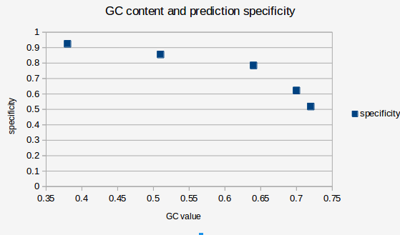

Fig 5. GC content and prediction specificity

The higher the GC content is, the more likely the ORFs starts with GTG instead of ATG. We should also include other possible start codons in the predictor.

For the final part, evolutionary relationship analysis, we chose dinucleotide frequencies to calculate the distance between genomes and visualized the evolutionary relationship between species in a phylogenetic tree using neighbour-joining method (Fig 6). The motivation for chosing dinucleotide frequencies for distance calculation is that it has been shown that dinucleotide frequency distributions are quite species specific and are even considered a genomic signature (Karlin and Burge, 1995). Secondly, we have chosen this distance calculation method over methods using amino acid/diamino acid frequencies because it is not based on prediction.
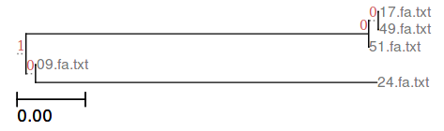

Fig 6. Evolutionary relationship between species based on dinucleotide frequencies

The tree agrees with the consensus tree built using gene order to calculate distances between species (Fig 7.)

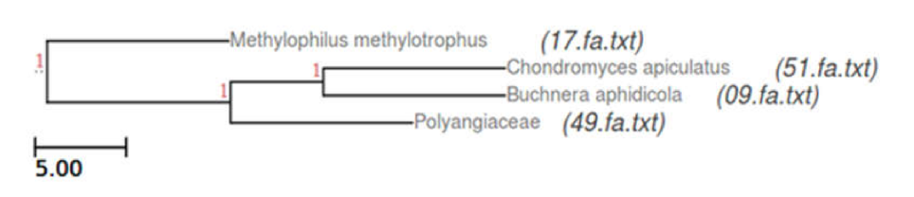
Fig 7. Evolutionary relationship between species based on gene order

